Appendix 4

THE HOUSING ESTATES AND HOUSING LAND, LONDON BOROUGH OF HARROW
PUBLIC SPACES PROTECTION ORDER 2023

This Order relates to Housing Estates and Housing Land in the London Borough of Harrow, as shown highlighted on the attached plan.

1. In this Order:

‘Anti-Social Behaviour’ refers to section 59 (2) (a)-(b) of the Anti-Social Behaviour, Crime and Policing Act 2014 and means: activities carried out, or which are likely to be carried out, in a public space which have a detrimental effect on the quality of life those in the locality. This also means behaviour likely to cause harassment, distress or alarm to one or more other person. This can include, but is not limited to, littering, verbal abuse, obstructing the highway, illegal drug use, urinating or, spitting

‘The designated area’ refers to any public space to which the public or a part of the public has access (S 74(1) of the Anti-Social Behaviour, Crime and Policing Act 2014). This can be with payment, or with express or implied permission. This can include businesses and communal areas of housing blocks but excludes residential premises.

‘Authorised officer’ refers to: police officer, police community support officer, or any other person designated to enforce the Order by London Borough of Harrow. You can require any authorised officers to produce authorisation before enforcing the Order.

2. The London Borough of Harrow, in accordance with Section 59 (7)(a) of the Anti-Social Behaviour, Crime and Policing 2014, identifies the following activities in the designated areas, highlighted in section 3 to 12 of this Order, as having had a detrimental impact on the quality of life of those in the locality, or it is likely that they will have such an effect.

3. Housing Estates and Housing Land as shown highlighted on the attached plan in Appendix 1 (‘the designated area’):
- Disperse from an area when asked
- Causing an obstruction which prevents or hinders the free passage of pedestrians or vehicles
- Leaving waste outside the bins
- Leaving food exposed for wildlife and attracting vermin

Due to the volume of reports of these activities and behaviours, the Council is satisfied that the effect, or likely effect, of the activities is, or is likely to be, of a persistent or continuing nature and these activities are unreasonable and justify the restrictions imposed by the notice and that it is in all the circumstances expedient to make this Order for the purpose of reducing anti-social behaviour in a public place.

The London Borough of Harrow, being thereby satisfied that the conditions in Section 59 of the Act have been met, hereby makes the following Order:

4. Housing Estates (in addition to Whole Borough requirements and prohibitions)

As shown highlighted on the attached plan in Appendix 1 (‘the designated area’)

Requirements - In all public spaces within this designated area, you are required to:

1) Disperse from an area when asked

- Disperse from an area when asked by an authorised officer because they reasonably believe that you have been or are obstructing the entrance to or exit from any building or, you have obstructed the free passage of people on or in communal areas without reasonable excuse.

2) Cease causing an obstruction when asked

a. Cease to cause an obstruction if asked to do so by an authorised officer because they reasonably believe you have been causing an obstruction.

b. Remove all items/vehicles/structures if asked to do so by an authorised officer because they reasonably believe you have been causing an obstruction by leaving or allowing the leaving of items/vehicles/structures in an area where they prevent or hinder the free passage of pedestrians or vehicles.

Prohibitions - In all public spaces within this designated area, you are prohibited from:

3) Leaving waste outside the bins

a. leaving and/or depositing any rubbish or waste, including but not limited to household waste, and builders waste outside of any bin or receptacle provided for this purpose.

4) Leaving food exposed for wildlife and attracting vermin

a Purposely depositing food or animal feed to attract or feed wildlife in an area identified ‘no feeding’ by signage. This does not apply to the feeding of any animals that you may own or be responsible for

5. Duration

The Order comes into effect on [date 2023] and will be in effect for a period of three years, [Date 2026].

If there is need to do so, the Council may shorten, extend or vary the order at any time in the three years. If the Council wants to extend or vary the Order, they must consult appropriate community representatives, the police and owners of the affected land on the variation.

6. Appeal

If any ‘interested person’ (a person living in, working in, or regularly visiting the affected area) wishes to appeal this Order, they must do so on one of two grounds (s 66 of the Anti-Social Behaviour, Crime and Policing Act 2014):

1) The Council did not have the legal power to make the Order.

2) The Council did not follow all the requirements listed in Chapter 2 of the Anti-Social Behaviour, Crime and Policing Act 2014.

The interested person(s) must appeal the Order with an application to the High Court within six weeks of the Order being made.

7. Information

Further information about the PSPO and matters related within it, can be found at www.harrow.gov.uk/licensing

8. Appendices

1 Designated area - Housing Estates and Housing Land

Appendix 1

Designated area - Housing Estates and Housing Land

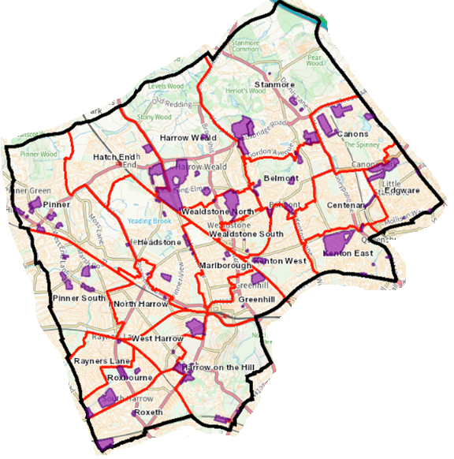

- Chaucer House Estate
- Arrowhead Parade Estate
- Mercer Place Estate
- Anmer Estate
- Edgware Golf Course Estate
- Oxhey Lane Estate
- Canon Croft Estate
- Anthoneys Estate
- Belmont Lodge Estate
- Belmont Circle Estate
- Byron Road Estate
- Canons Park Estate
- Christchurch Avenue Estate
- Churchill Place Estate
- Chigwellhurst Estate
- Dennis Lane Estate
- Cullington Close Estate
- George V Close Estate
- Elmgrove Estate
- Grove Estate
- Harrow View Estate
- Harrow Weald Park Estate
- Headstone Lane Estate
- High Road Estate
- Honister Place Estate
- Kenmore Park Estate
- Kenton Lane Estate
- Kingsfield Estate
- Little Common Estate
- Marsh Road Estate
- Mountside Estate
- Pinner Hill Estate
- Pinner Road (301) Estate
- Wealdstone House Estate
- West End Lane Estate
- Wolverton Road Estate
- Headstone (GLC) Estate
- Glebe Estate
- Manor House Estate
- Mill Farm Close Estate
- Moat Drive Estate
- Parkfield Estate
- Pinner Green Estate
- College Hill Road Estate
- Towers Estate
- Weald Village Estate
- Wealdstone House Estate
- Whittington Way Estate
- Woodlands Estate
- Woodlands Drive Estate
- Cottesmore Estate

